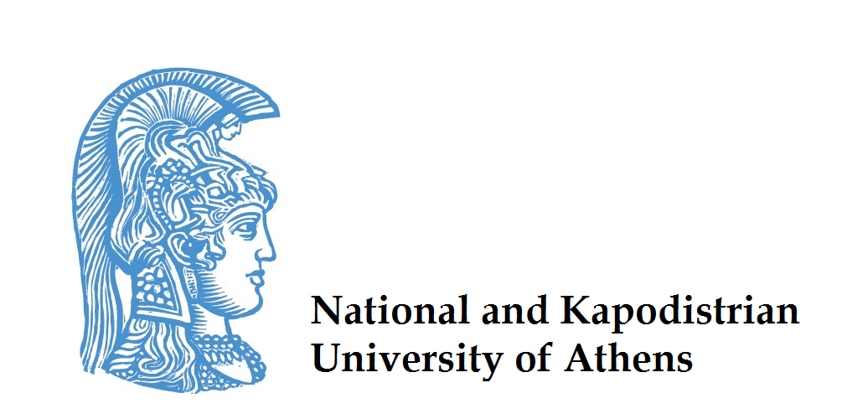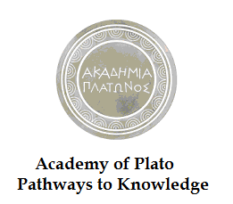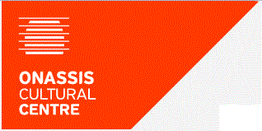


Plato’s Academy: Pathways to Knowledge
Call for the expression of interest by students for the summer school of Philosophy and Applied Research
13-27 July 2014
The Foundation for Hellenic World (FHW) in collaboration with the University of Athens and the Onassis Cultural Center is launching a project entitled «Plato's Academy: the development of Knowledge and innovative ideas».
The objectives of the project are the following
- the support of research concerning the development of knowledge and innovative ideas as a contributing factor to social and economic progress
- the development of a network of cooperation connecting Greek and overseas educational establishments, as well as individual researchers and research institutions
- the utilization of a historical neighborhood of Athens and its cultural heritage as the starting point for the acquisition of knowledge and for the development of alternative learning methods.
Within the framework of this project, FHW organizes and runs a multidisciplinary summer school the overall theme of which will be to consider the impact of Platonic (mainly) philosophy on contemporary issues relevant to science and technology..
This year’s summer school hosts some of the leading philosophers and thinkers from USA and EU Universities with special emphasis on ancient Greek and modern philosophy. Academics such as John Cooper from Princeton University/USA, Hans-Johann Glock from Zurich University/Switzerland, Alexander Mourelatos from Texas University/USA, Eric Schliesser from Ghent University/ Belgium and Genia Schönbaumsfeld, Southampton University /United Kingdom as well as Vaso Kindi, Theodoros Arabatzis and Stelios Virvidakis from the University of Athens.
The Summer School of Philosophy and Applied Research is addressed to postgraduate students and researchers from all over the world, from mainly scientific and technological backgrounds who are interested in investigating the relationship between applied research and its underlying principles, and the ways in which applied research supplies feedback for, and occasionally overturns, these same principles. The number of students who will participate will be twenty. They will be selected by a special committee following the thorough assessment of the submitted applications
The Project covers the teaching expenses and the educational materials provided. Additionally, it fully covers the students' meals and accommodation in twin bedrooms, as well as their daily transportation to and from the teaching venues. Lastly, the Project will cover 3 educational outings in and around Athens which are part of the summer school program. The students will have to cover the transportation cost from their place of residence to Athens and back.
The Summer School will last 15 days and will run for three consecutive years, starting 2012. The venue will be the facilities of FHW in Athens, specifically the Hellenic Cosmos (www.hellenic-cosmos.gr/). The opening date for the current year (2014) is Sunday, July 13th and the closing date is Sunday, July 27th.
The programme includes 32 hours of lectures, 16 hours of workshops and 3 visits to sites of historical and archaeological interest, where specific activities related to the programme will be carried out. The language of instruction will be English and the teachers/instructors will be academics, researchers and specialized scientists whose research focuses on seeking the connection between philosophy, science and technology either from a scientific or a philosophical point of view.
During the summer school the issues which will be examined and presented will be both practical and methodological, drawn from various themes such as the basic principles of Platonic Philosophy, Bioethics, Theory of Knowledge, Philosophy of Language and Communication, Ethics, Logic, Philosophy of Mathematics, Philosophy of Science, Philosophy of Mind etc.
The detailed programme of instruction will be soon published in the summer school's link http://summerschool.fhw.gr/plato
Artificial Intelligence, Philosophy of the Mind etc.
- Call for expressions of interest - candidate students for the Summer School 2014
- Application Form
Publication date: 09-04-2014

Deadline for the applications: 31th May 2014
Selection process to be completed: 10th Jun 2014.

Please do not forget to include the reference code: plato2014 in any communication.

